**Practical Workbook**

**Fundamentals of Information Technology**



Name : ___________________________

Year : ___________________________

Batch : ___________________________

Roll No : ___________________________

Department: ___________________________

**Edition –Fall 2017-18**

**Department of Software Engineering**

**NED University of Engineering & Technology,**

**Karachi – 75270, Pakistan**

**Workbook**

**Fundamentals of Engineering and Technology**

**(CT-174)**

Prepared by

**Engr.Simra Najm**

Approved by

Chairman

**Department of Software Engineering**

**INDEX**

|  |  |  |
| --- | --- | --- |
| ***Lab No.*** | ***Object*** | ***Signature*** |
| 1. | Familiarization with DOS environment and its important commands |  |
| 2. | Learning some configuration commands & creating batch files in DOS |  |
|  | environment |  |
|  |  |  |
| 3. | Understanding network sharing and working with Windows 8 |  |
|  |  |  |
| 4. | Learning basics of Microsoft Word |  |
|  |  |  |
| 5. | Exploring the advanced features of Microsoft Word |  |
|  |  |  |
| 6. | Creating Bookmarks, Hyperlink, Mail Merge |  |
|  |  |  |
| 7. | To learn the basics of Microsoft excel |  |
|  |  |  |
| 8. | Working with Formulas in Microsoft Excel |  |
|  |  |  |
| 9. | Working with conditions, logical &Trigonometric functions in Microsoft Excel |  |
|  |  |  |
| 10 | To learn how to depict data graphically in Excel |  |
|  |  |  |
| 11. | Creating databases using Microsoft Access |  |
|  |  |  |
| 12. | Creating queries, forms and reports in Microsoft Access |  |
|  |  |  |
| 13. | Familiarization with the environment of Microsoft Power Point |  |
|  |  |  |
| 14. | To learn the concept of Action Buttons and Invisible Buttons in Microsoft Power Point |  |

**FIT** **Lab Session 01**

***NED University of Engineering & Technology – Department of Software Engineering***

**Lab Session 01**

**OBJECT**

***Familiarization with DOS environment and its important commands.***

**WORKING WITH DOS**

**Understanding DOS**

DOS, the acronym for Disk Operating System, is an operating system with a command-line interface used on personal computers. It provides a set of commands that enables the users to access or manipulate information on their disks, as well as simply interact with their computer.

**Dos Commands**

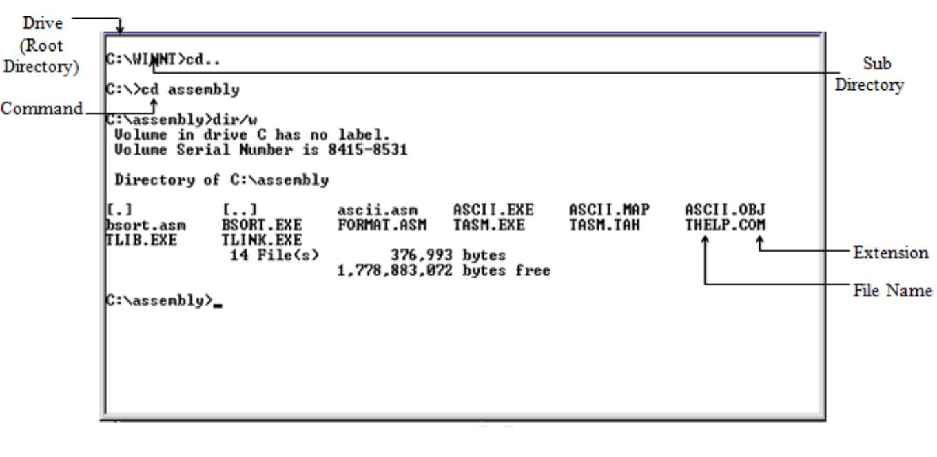

**Figure 1.1: DOS environment**

DOS commands are of two types namely internal commands and external commands.

* Internal commands are those which are built into command.com.
* External commands are those that must be located from a file loaded by command.com before it can be executed.

A brief description of important DOS commands is given below:

**Changing drive**

Type drive letter of the drive to which you want to switch to, on the command prompt followed by ‘:’

Example: c:>d: This will change the current drive from C to D.

Result: d:>

2

3

**FIT** **Lab Session 01**

***NED University of Engineering & Technology – Department of Software Engineering***

**Wild Cards**

DOS recognizes two wild cards:

* The asterisk (*) represents one or more characters that a group of files has in common.
* The question mark (?) represents a single character that a group of files has in common.

**Working with Directories**

• **dir** to view the contents of a directory

Prompt on screen: drive:>

Syntax: dir

Example: c:>dir This will list all the files and subdirectories on drive C, which is being prompted on screen. If another drive needs to be accessed, first change the drive, as previously explained and then enter the **dir** command.

Use wild cards to display selected lists. For example:

- dir *.* Displays all files and subdirectories on the drive

* dir ?????.comDisplays all files having names up to five characters and extension **‘com’**

dir command can be modified using these wild cards and other switches as follows so that only one screen of selected information is displayed at a time.

* **Cd** to change from one directory to another

Prompt on screen: drive:>

Syntax: cd drive:\path

Example: c:>cd dos This will change the current directory from the root directory to

**‘dos’** directory on the prompted drive C.

Result: c:\dos>

* **md** to create a new directoryPrompt on screen: drive:>

Syntax: md drive:\path\dirname

Example: c:>md neduetThis will create a new directory, named **‘neduet’** on the

drive being prompted, in this case drive C.

• **cd..** to switch back one level up in the directory structurePrompt on screen: drive:>

Syntax: cd..

Example: c:\dos\subdos>cd.. This will switch back to the directory, **‘dos’** from the current directory, **‘subdos’** of the prompted drive C.

Result: c:\dos>

**FIT** **Lab Session 01**

***NED University of Engineering & Technology – Department of Software Engineering***

* **cd\** to switch back to the root drive directoryPrompt on screen: drive:>

Syntax: cd\

Example: c:\dos\subdos>cd\ This will switch back to the root drive, C

Result: c:\>

* **rd** to remove a directoryPrompt on screen: drive:>

Syntax: rd drive:\path\dirname

Example: c:\>rd neduetThis will delete the directory, named **‘neduet’** from the

prompted drive C.

* **tree** to view directory listing in a hierarchical structure.Prompt on screen: drive:>

Syntax: tree drive:\path

Example: tree d:This will display the hierarchical directory structure of drive D.

Use /f to display the names of the folders as well as the files in each folder, in a hierarchical manner.

**Working with Files**

* **copy** to copy a file from one directory or drive to anotherPrompt on screen: drive:>

Syntax: copy drive:\source path\filename drive:\destination path\ filename

Example: copy c:\neduet\cfile.exe c:\windows

This will copy the file, named ***‘cfile.exe’*** from **‘neduet’** directory to **‘windows’** directory with the same name for the new file.

* **ren** to rename a filePrompt on screen: drive:>

Syntax: ren drive:\path\old filename drive:\path\new filename

Example: c:\>ren cfile.exe edit.exe

This will rename the file ***‘cfile.exe’*** to ***‘edit.exe’*** in the prompted drive C.

* **del** to delete a filePrompt on screen: drive:>

Syntax: del drive:\path\filename

Example: c:\>del cfile.exe This will delete the file, ***‘cfile.exe’*** present in the prompted drive C.

Wild cards can also be used with any of the above commands to work with group of files.

* **Type** to view a file on the screen. Only text based files can be viewed, as DOS supports only such files.

Prompt on screen: drive:>

Syntax: type drive:\path\filename

4

|  |  |
| --- | --- |
| **FIT** | **Lab Session 01** |
| ***NED University of Engineering & Technology – Department of Software Engineering*** | |
| Example: c:\>type cfile.txt | This will list ***‘cfile.txt’***. |

Files longer than one screen scroll off to the top. To avoid this, use |more suffix following the command**.**

Example: c:\>type cfile.txt |more **Disk Management**

* **format** to format a diskPrompt on screen: drive:> Syntax: format drive:

Example: c:\>format Z: This will format Flash memory stick in *drive Z*.

* **chkdsk** to get a report on statistics of the diskPrompt on screen: drive:>

Syntax: chkdsk drive:

Example: c:\>chkdsk c: This will generate a report on statistics of *drive C*.

* **vol** to view a disk’s volume label and it’s serial number

Prompt on screen: drive:>

Syntax: vol drive:

Example: c:\>vol d: This will display volume label of *drive d*.

* **ver** to find current version of DOS installed on your systemPrompt on screen: drive:>

Syntax: ver

Example: c:\>ver This will display the current version of DOS on your system.

**EXERCISE**

1. Write command to display all files having extension ‘docx’.

______________________________________________________________________

1. Write command to display all files of all types starting with letter ‘s’.

______________________________________________________________________

1. Write a command to copy the file *assignment* of type *docx* from the directory ‘ITC’ of drive D to drive F.

______________________________________________________________________

1. Write a command to delete the directory as well as the files of the directory ‘*world*’ on drive E.
2. Write command to copy all the files beginning with ‘m’ and whose file names has a ‘txt’ extension from drive A to the ‘\document’ directory on drive C.

______________________________________________________________________

1. Write set of commands to create a directory ‘practical’ on drive F, and then move into it. Now list all files present in it, then go back to root drive F.

___________________________________________________________________________

___________________________________________________________________________

___________________________________________________________________________

_________________________________________________________________________

______________________________________________________________________